**Database Administrator Privileges**

**By: Kevin Litchmore**

**Agenda:**

We will be granting privileges on different tables to several different users. Privileges will dictate the action the user will be able to perform on the designated table.

**Assumptions:**

1. Users will be granted privileges following a least privilege schema.
2. The faculty members are the employees while the students are the customers.

**Privilege Schema:**

|  |  |  |
| --- | --- | --- |
| **TABLE** | **USER** | **PRIVLEDGE** |
| **STUDENT** | **ABLE** | **SELECT** |
| **STUDENT** | **BAKER** | **SELECT, UPDATE** |
| **STUDENT** | **CHARLES** | **SELECT, INSERT** |
| **STUDENT** | **DRAKE** | **SELECT, DELETE** |
| **STUDENT** | **ELLIOT** | **SELECT, UPDATE ON MAJOR ONLY** |
| **FACULTY** | **MARTIN** | **SELECT, UPDATE** |
| **FACULTY** | **SEAVER** | **SELECT, INSERT, DELETE** |
| **FACULTY** | **LOONEY** | **SELECT, UPDATE ON ADDRESS ONLY** |
| **FACULTY** | **MILLS** | **SELECT, UPDATE, INSERT** |

**Able**

**Granted Privileges:**

SQL> select * from admin.student;

**Denied Privileges:**

SQL> select * from admin.faculty;

SQL> update admin.student set major='haha' where studentid=100;

**Baker**

**Granted Privileges:**

SQL> select * from admin.student;

SQL> update admin.student set major='haha' where studentid=100;

SELECT * FROM ADMIN.STUDENT;

**Denied Privileges:**

SQL> select * from admin.faculty;

SQL> update admin.faculty set name='haha' where facultyid=0980;

SQL> DELETE FROM ADMIN.STUDENT WHERE NAME LIKE '%ABL_%';

**Charles**

**Granted Privileges:**

SQL> select * from admin.student;

SQL> insert into admin.student (studentid,name,major,status,age,address,gpa) values (050, 'Kevin', 'Reading', 'TM', 45, '1 New York', 2.75);



Select * from admin.student;

**Denied privileges:**

SQL> select * from admin.faculty;

SQL> insert into admin.faculty (facultyid, name, department, address, rank) values(970, 'Brain', 'hb', '45 new york', 'instructor');

**Drake**

**Granted Privileges:**

select * from admin.student;

SQL> delete from admin.student where age like '%1_%';

SQL> select * from admin.student;

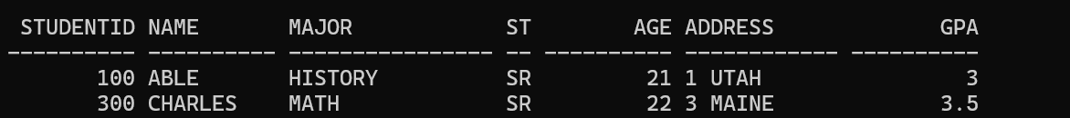

**Denied Privileges:**

SQL> update admin.student set name='ashley' where name ='able';

**Elliot**

**Granted Privileges:**

select * from admin.student;

SQL> update admin.student set major = 'ENGLISH' where STUDENTID='200';

select * from admin.student;

**Denied Privileges:**

SQL> update admin.student set address = 'newyork' where address='utah';

update admin.student set address = 'newyork' where address='utah'

SQL> select * from admin.faculty;

**Martin**

Granted Privileges:

select * from admin.faculty;

SQL> update admin.faculty set address='44 manhattan' where facultyid='5430';

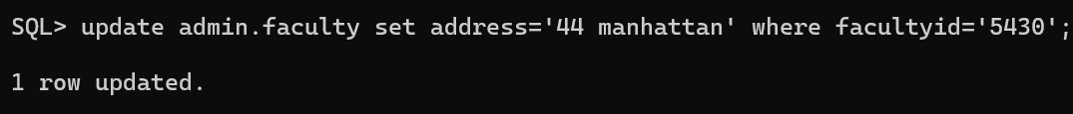

SQL> select * from admin.faculty;

**Denied Privileges:**

SQL> select * from admin.student;

SQL> update admin.student set address='44 manhattan' where studentid='100';

Seaver

**Granted Privileges:**

SQL> SELECT * FROM ADMIN.FACULTY;

SQL> INSERT INTO ADMIN.FACULTY VALUES( '768', 'BILL','GH', '345 MD', 'DEAN');



SQL> SELECT * FROM ADMIN.FACULTY;

SQL> DELETE FROM ADMIN.FACULTY WHERE FACULTYID='768';

Select * from admin.faculty;

Denied privileges:

SQL> UPDATE ADMIN.

**Looney**

**Granted Privileges:**

SQL> SELECT * FROM ADMIN.FACULTY;

UPDATE ADMIN.FACULTY SET ADDRESS= '1 NORTH' WHERE FACULTYID ='980';



SQL> SELECT * FROM ADMIN.FACULTY;

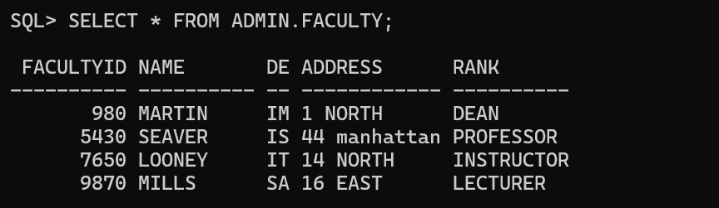

**Denied Privileges**:

SQL> UPDATE ADMIN.FACULTY SET NAME= 'KING' WHERE FACULTYID ='980';

SQL> DELETE FROM ADMIN.FACULTY WHERE FACULTYID='980';

SQL> INSERT INTO ADMIN.FACULTY VALUES( '1', 'KING', 'GA', '17 WEST', 'DEAN');

**Mills**

**Granted Privileges:**

UPDATE ADMIN.FACULTY SET NAME= 'JEAN' WHERE FACULTYID ='980';

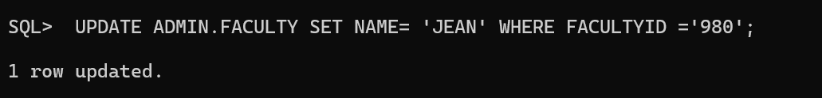

SQL> SELECT * FROM ADMIN.FACULTY;

SQL> INSERT INTO ADMIN.FACULTY VALUES ('678', 'TOM', 'GH', '1 FIRETOWN', 'INSTRUCTOR');



SQL> SELECT * FROM ADMIN.FACULTY;

**Denied Privileges:**

SQL> DELETE FROM ADMIN.FACULTY WHERE NAME LIKE '%TO_%';

